注意：请应聘译员从下列六种类型的文稿译稿中**选择3篇试译（根据自己擅长的类型自选3篇）**。译文直接跟在英文原文下方即可。

1. **电影版权交易合同**

**（翻译要求：英文功底较强，理解准确；中文表达简练、准确，符合合同文的语体风格；注重查证行业用语，遵循行业表述习惯）**

**样稿：**Licensor will not be obligated to deliver to Distributor any Delivery Materials until 100% of the License Fee for the Picture has been remitted by Distributor and Distributor shall not exploit the Pictures in any of the Licensed Rights until the full License Fee has been received by Licensor. Distributor acknowledges and agrees that time is of the essence and the payment schedule set forth herein will be strictly enforced. Failure to pay by the due dates herein will result in Licensor having the right to terminate this Agreement. **//** （译文）在发行方将全额（100%）许可费汇至许可方银行账户之前，许可方不负有向发行方交付任何影片物料的义务；且在许可方收到全额许可费之前，发行方不得行使有关协议影片的任一许可权利。发行方谨此确认并同意：时间为协议之核心要素，且本协议中所规定的支付进度必须严格执行。如发行方未能在本协议中规定的到期日支付相应款项，则许可方有权终止本协议。

试译：

CERTIFICATE OF ENGAGEMENT

For good and valuable consideration, receipt and sufficiency of which is hereby acknowledged, the undersigned does hereby acknowledge, certify and agree that all of the results and proceeds of _____________’s services rendered for _______________ (“Company”) or otherwise in connection with __________________ the (“Picture”) including, without limitation, all material of whatever kind or nature, including all literary or dramatic material, writing services, supervisory services, ideas and/or “gags”, suggestions and ideas of every kind written or submitted to Company at any time to date or hereafter (all such material, services and results and proceeds thereof shall be collectively referred to herein as “Material”), in connection Picture (i) are and/or will be solely created by _____________ as the employee-for-hire of Company within the scope of _______________’s employment or, if not, was specially ordered or commissioned as part of a motion picture or other audio-visual work, and (ii) in any such case such Material is and shall be considered a work-made-for-hire for Company within the meaning of the U.S. Copyright Law and Company shall be deemed the author thereof, and accordingly, shall and does own all right, title and interest therein of every kind or nature, whether now known or hereafter devised, including, without limitation, the entire copyright (including all extensions and renewals) therein throughout the universe in perpetuity with, among other things, the right to make any and all changes in the Material. If the Material or any part thereof shall ever be determined not to be a work-made-for-hire, the undersigned hereby irrevocably and exclusively assigns to Company, throughout the universe in perpetuity, all right, title and interest (including, without limitation, the copyright therein and all extensions and renewals thereof) in and to the Material.

1. **领事馆公文**

**（翻译要求：理解透彻，注意中英思维转换，中文表达自然、地道，忌拗口直译）**

**样稿：**Brought to you by the British Council, the Study UK Showcase 2017 is an exciting, informative and interactive exhibition that allows visitors to explore and engage directly with a wide range of inspirational creations produced by UK students, alumni and academics. **//**(译文) 由英国文化教育协会主办的2017留学英国展会融趣味性、知识性和互动性于一体，可使观众近距离欣赏由英国优秀学子、校友和学者创作的一系列鼓舞人心的作品。

**试译：**

**English is GREAT Teacher Award to recognise Chinese non-native speaking teachers of English across China**

The British Council has launched the English is GREAT Teacher Award 2018, which will celebrate the most outstanding Chinese non-native speaking teachers of English across China. The Award will recognise individuals who make a profound impact on students by sharing their passion for the English language.

The English is GREAT Teacher Award is part of the English is GREAT campaign, which was announced during the UK Prime Minister’s visit to China in January 2018. It promotes English as a tool for China to interact with the wider world, supporting China’s ambitions to boost spoken English proficiency and build a globally ready workforce.

We spoke with Zheng Jianwei, a visually-impaired English language teacher and winner of the British Council’s 2016 Study UK Alumni Awards, about how English changed his life.

1. **海关公文**

**（翻译要求：提前了解、查阅相关行业知识，中文表达成熟、规范、正式，语言简练、表达明确，符合行业表述习惯和官方公文语体风格）**

**样稿：**The growing trade in electronic commerce (E-Commerce) has generated enormous opportunities for the global economy, providing new growth engines, developing new trade modes, driving new consumption trends and creating new jobs. This unprecedented growth has revolutionized the way businesses and consumers market, sell, and purchase goods, providing wider choices, advance shipping, payment and delivery options. It has also opened up global economic opportunities to micro, small and medium enterprises (MSMEs) in terms of wider access to overseas markets by lowering entry barriers and reduced costs. **//**（译文）跨境电商交易规模的持续增长为全球经济的发展带来了重大机遇，有利于培育发展新动能、构建贸易新模式、引领消费新趋势、创造就业新岗位。电商的迅猛发展不仅极大地改变了企业和消费者的货物营销和买卖方式，为其提供了提前运送、支付和交付等更多选择，而且为众多中小微企业参与全球经济带来了重大机遇，减少了其进入海外市场的准入障碍和成本。

**试译：**

Several challenges lie ahead for Customs and other border agencies due to the specificities of emerging business models and processing capacities of cross-border e-commerce transactions, as well as the nature of E-Commerce actors involved. New operating models are being developed to manage local trading environments and domestic legislation. Suppliers/vendors are increasingly becoming ‘drop shippers’ who can be based anywhere and never physically be in possession of the goods. The rapid proliferation of online retailers offering consumers competitively priced products is likely to further facilitate inadvertent or deliberate non-compliant activities such as fraud. The growth in cross-border E-Commerce flows has seen an increase in prohibited and restricted goods arriving via fragmented and personalized parcel streams. This phenomenon is also witnessing the growing presence of the ‘DarkNet’ illicit trade environment. There is a need for the elaboration of well-defined roles and responsibilities of each stakeholder; effective risk management, maximum use of technology, and smart controls.

1. **剧本/小说**

**（翻译要求：原文理解透彻，掌握人物形象、故事脉络，中文表达自然、顺畅）**

**样稿：**The rising EARTH is WREATHED IN FIRE ... William gazes across the gulf of space, seemingly a lone witness to the APOCALYPSE. He can't breathe, can't look away — weightless TEARS collect in his eyes. Tendrils of PLASMA curl from the Earth's surface, REACH out into the darkness. The planet emerges entirely, reveals a point of blinding light: the OCCLUDED SUN ... William DEFLATES in relief, unsure if he should laugh or CRY. He pulls back from the precipice, folds into a corner. **//**（译文）正在升起的地球被火光环绕……威廉盯着深渊般的太空，像一个孤独的世界末日见证者。他无法呼吸，也无法转过头去当作视而不见。他的眼中泛起泪光。**（视角切换）**地球表面卷起卷状的等离子体，伸向夜空中，这个星球终于完全出现了，发射出耀眼光芒：原来（不是地球）是被遮挡的太阳。威廉松了一口气，不知道是该笑还是该哭。他把自己从悬崖般的舱口拉回，蜷缩在角落里。

**试译：**

**WHO IS CHESTER WONG?**

When we meet Chester Wong, our hero, he is a stranger to himself. Chester, age 35, is a dashing yet humble man of action who does not know who he is or where he belongs in the world. By the movie's end, he understands who he is and accepts himself as someone who is both warrior and peacemaker. A son and a grown man. A lethal enemy and a friend to others. A diplomat and enforcer. A lover and fighter. A man of dichotomies. He comes to peace with himself as someone who loves danger, risk, and doing good for others for its own sake, embracing the yin/yang of his personality. This embrace of his "warrior" side and of filial piety makes him more human, makes him a better son, a better friend, and makes him known to himself. It also makes him a fascinating person, attractive to women and envied by men. Chester's journey ends, as does the movie, with him establishing his own Hong Kong business as a professional white-collar executive who runs a security business involved with dangerous and intriguing missions fighting for justice. He's also reunited with a true love of his life, Peggy (more on this later in the treatment). He's come full circle from when we met him. He's now a wholly integrated man of action. Future movies will be able to dramatize the "undoing" of Chester's hard-won self-knowledge and his family life, much like Jason Bourne's own search for identity. Chester Wong is always a man in search of himself as he fights for justice.

1. **美妆**

**（翻译要求：用于品牌和产品推介，语言风格可适当华丽、高调，表达成熟，也可适当运用感叹句、疑问句等感情色彩强烈的表达方式以及第二人称的对话式风格，拉近与消费者的距离。）**

**样稿：**A revolutionary anti-aging serum designed to even the skin tone, reduce wrinkles, and preserve a youthful appearance. Formulated with the stem cells of a rare Swiss apple, this combination of rich proteins, phytonutrients, and metabolites boosts cell production and protects your skin from environmental stress. **//**（译文） Swiss Apple Facial Serum瑞士苹果面部精华，Indie Lee家革命性抗衰老精华，可均匀肤色，抚平皱纹，让你的肌肤永葆年轻态！产品富含苹果干细胞，取自瑞士稀有苹果，同时添加丰富蛋白质、植物营养成分以及天然代谢物，可促进细胞生成，保护肌肤免遭环境压力侵害。

**试译（产品介绍）：**

Our Avocado & Jojoba Hydrating Day Cream brings long-lasting hydration to dry and dehydrated sensitive skin. Free from drying alcohols and irritating ingredients, this light, buttery Moisturiser instantly plumps fine lines and smoothes away dry patches without feeling greasy or heavy on the skin. Enriched with organic Avocado and Jojoba oils to deeply condition lackluster skin with Omegas 3 & 6, it leaves sensitive skin calm, supple and touchably soft. Delicately scented with Jasmine and May Chang, the silky formula melts away to reveal a glowing and revitalized complexion.

#####Why It’s Special  
* Provides long-lasting hydration to dry and dehydrated skin.   
* Nourishing Avocado and Jojoba extracts soothe and quench skin.   
* Non-greasy cream leaves skin calm, supple and soft.

**F．艺术简介**

**（翻译要求：表述准确，对专有表达和事实信息进行查证，且能够在准确理解原文的基础上脱离原文束缚，整合信息，使语言优美、流畅、韵律十足，营造出浓郁的艺术氛围。）**



**样稿：**

Emerging from a misty blue haze, a beautiful young woman plucks a fruit from a tree, while a mystical violinist plays next to her. Behind them stretches a rural street scene from Chagall’s beloved hometown in Russia, Vitebsk. With iridescent, delicate colors and soft application of medium, Chagall’s *L’Aubade*, executed in 1972, is a mirage of magical lyricism and blissful romance. Encompassing Chagall’s favored themes of love, memory, music and fantasy, *L’Aubade* exemplifies the artist’s unique and deeply personal artistic vision, a beautifully composed work that comes from a period of great happiness and stability for the artist.

朦朦胧胧的蓝色雾霭中，美丽的少女正要从树上摘下果实，身旁有一位神秘的小提琴手正在对她弹奏。而在他们身后，一条乡间小路横亘画面，向远处绵延，两侧的田园景色，其原型正是马克·夏卡尔挚爱的家乡——当时苏联的维切布斯克。这就是夏卡尔于1972年创作的《晨歌》，画作的色彩荧亮柔和，作画手法细腻轻柔，描绘出了充满奇幻诗意和甜蜜爱情的绝美幻境。《晨歌》创作于艺术家享受幸福与平静的时期，包含了艺术家所钟爱的主题：爱、回忆、音乐和幻想，展现出了其独特且非常个性化的艺术视角。

*L'Aubade* is a pictorial representation of Chagall's belief in the idea of love, which for him was both motivation and motif. As he explained in 1958: "In it lies the true Art: from it comes my technique, my religion... All other things are a sheer waste of energy, waste of means, waste of life, of time... Art, without Love - whether we are ashamed or not to use that well-known word - such a plastic art would open the wrong door" (quoted in J. Baal-Teshuva, ed., *Chagall: A Retrospective*, Westport, 1995, p. 179).

对于夏卡尔而言，爱的信仰既是创作动机也是创作主题，《晨歌》就是这个信仰在绘画中的体现。正如他于1958年谈到的：「爱中自有艺术的真谛：我的技法，我的信仰皆由爱而生……描绘爱之外的事物纯属浪费精力、糟践方法、虚度人生和光阴……无论我们是否羞于提及「爱」这个人人熟知的字眼，没有爱的艺术只是毫无情感只重造型的艺术，它开启的将是错误的大门」（夏加尔语，1995年，引自《夏加尔回顾展》，雅各布·巴力-特舒法编辑，韦斯特波特，第179页）。

**试译：**

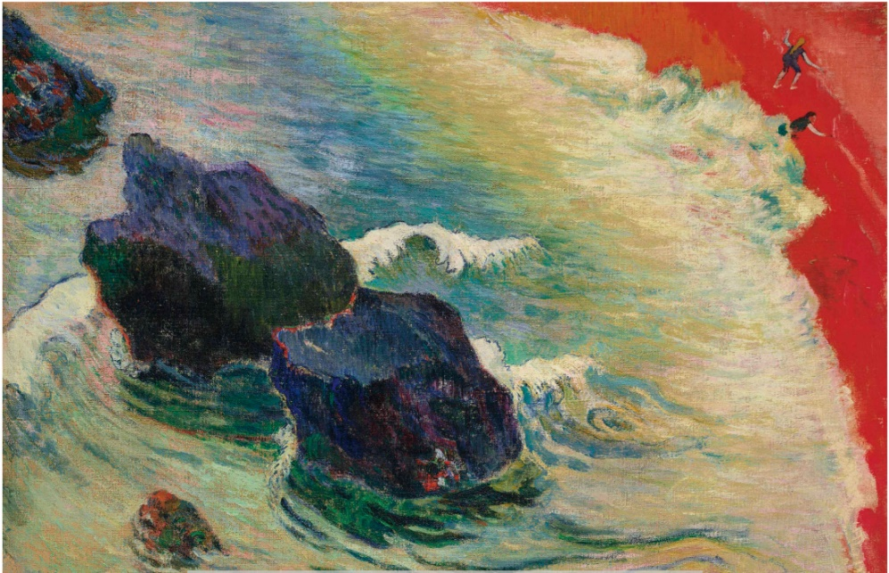

Gauguin *La Vague*

Gauguin was determined to take a decisive turn in his art—he would henceforth pursue a deeply subjective, anti-naturalist, primitivist, and visionary track, in a conception he and Bernard called synthétiste. “My latest things are coming along well and I think you’ll find…the affirmation of my earlier teachings,” Gauguin wrote to Schuffenecker on 14 August. He offered this advice: “Don’t copy nature too closely. Art is an abstraction; as you dream amid nature, extrapolate art from it and concentrate on what you will create as a result ” (D. Guérin, ed., op. cit., 1978, pp. 23-24).

In keeping with these ideas, Gauguin took liberties with the marine motif he had seen in Le Pouldu. Wayne Andersen located and photographed the site (op. cit., 1970). The third rock at upper left is a fiction the artist invented to extend the diagonal effect of the two actual formations. Most astonishing of all is that Gauguin painted the ordinary sand-colored beach a brilliant, utterly unnatural hue of vermilion. His increasingly idiosyncratic sense of color stemmed in part from the brilliant kiln-fired glazes that he applied to his ceramic heads and figures, in which the presence of red appears to animate the artist’s creation of flesh from clay. Gauguin’s vermilion in La Vague evokes the warmly pulsing life-blood in the generative body of maternal earth.